1. [What is IL code, CLR, CLS & JIT? - Part1](http://www.questpondvd.com/02456subcategquureutnpaotnhd9854.php?pp=298&propid=1&saleid=subscription)
2. [What is IL code, CLR, CLS & JIT? - Part2](http://www.questpondvd.com/02456subcategquureutnpaotnhd9854.php?pp=299&propid=2&saleid=subscription)

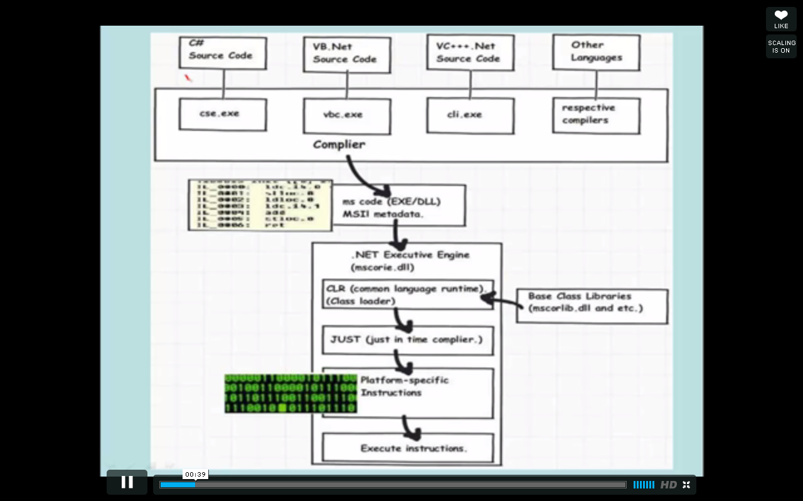

* + Write your code in any language (c#,vb.net, vc++.net or other languages) > compiler compiles this code into IL(Intermediate language ) and then CLR comes into picture and it converts the IL code to machine level code using JIT
  + **IL Code**

It's a CPU independent partially compiled code. We do not know in what kind of environment .NET code will run. In other words we do not know what can be the end operating system, CPU configuration, machine configuration, security configuration etc. So the IL code is half compiled and

on runtime this code is compiled to machine specific using the environmental properties(CPU,OS, machine configuration etc)

* + **CLR**

Common language runtime is the heart of .NET framework

And it does 4 primary important things:-

Garbage Collection

Code Access Security

Code Verification

IL to Native translation

* + **CTS**

In .NET there are lot of languages like C#, VB.NET, vC++.NET etc. There can be situations when we want code in one language to be called in other language. In order to ensure smooth communication between these languages the most important thing is that they should have a common type system. CTS ensure that data types defined in two different languages get compiled to a common data type.

* + **CLS**

CLS (Common Language Specification) is subset of CTS. CLS is a specification or set of rules or guidelines. When any programming language adheres to these set of rules

It can be consumed by any .NET language.

For instance one of the rule which makes your application CLS non-compliant is when you declare your methods members with same with only case differences in C#. You can try this create

Simple class in C# with same name and only case difference and try to consume the same in VB.NET it will no work.

* + **JIT**

JIT compiles the code just before execution and then saves this translation in memory.

* + **ILDSM** command is used to disassemble the Dll into IL code.

1. [What are 3 kind's of JIT & What is NGEN.exe?](http://www.questpondvd.com/02456subcategquureutnpaotnhd9854.php?pp=300&propid=3&saleid=subscription)

**Normal-JIT(Default)** - Normal-JIT compiles only those methods that are called at runtime cached.

**Econo-JIT** - compiles only those methods that are called at runtime No caching.

**Pre-JIT** - compiles complete source code into native code in a single compilation cycle. This is done at the time of deployment of the application. We can implement Pre-JIT by using ngen.exe

1. [What is CAS, evidence, permission set & code groups?](http://www.questpondvd.com/02456subcategquureutnpaotnhd9854.php?pp=296&propid=4&saleid=subscription)
2. [What are the changes in .NET 4.0 security model & What is sandboxing?](http://www.questpondvd.com/02456subcategquureutnpaotnhd9854.php?pp=297&propid=5&saleid=subscription)
3. [What is the difference between managed & unmanaged code?](http://www.questpondvd.com/02456subcategquureutnpaotnhd9854.php?pp=503&propid=6&saleid=subscription)

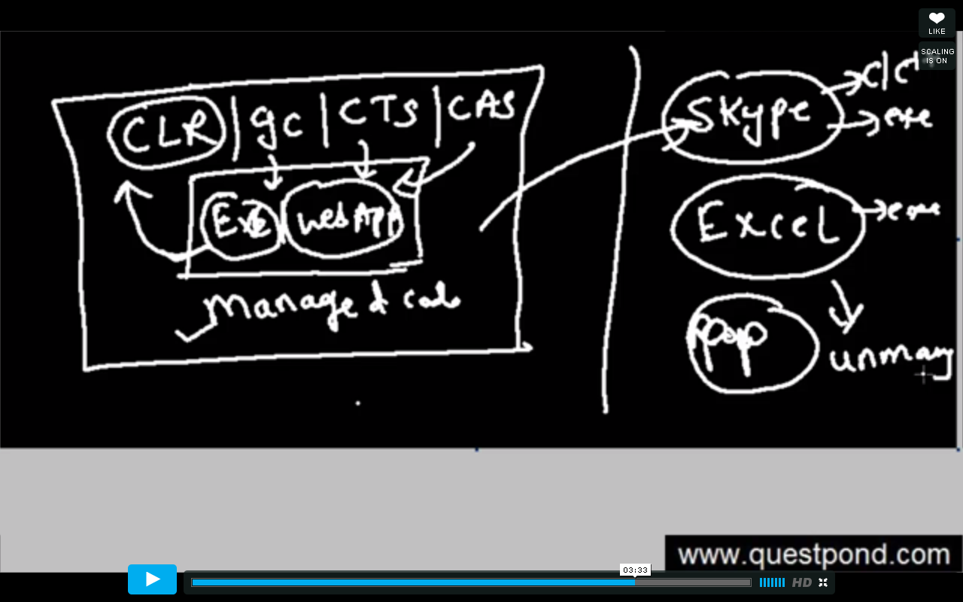

Managed code runs completely under control of CLR whereas unmanaged code won’t run under CLR.

1. [What is Garbage Collector Gen 0, 1 & 2?](http://www.questpondvd.com/02456subcategquureutnpaotnhd9854.php?pp=305&propid=7&saleid=subscription)

Garbage Collector (background thread) is a feature provided by CLR to clean **unused** **managed** **objects**. By cleaning those unused object basically it reclaims the memory.

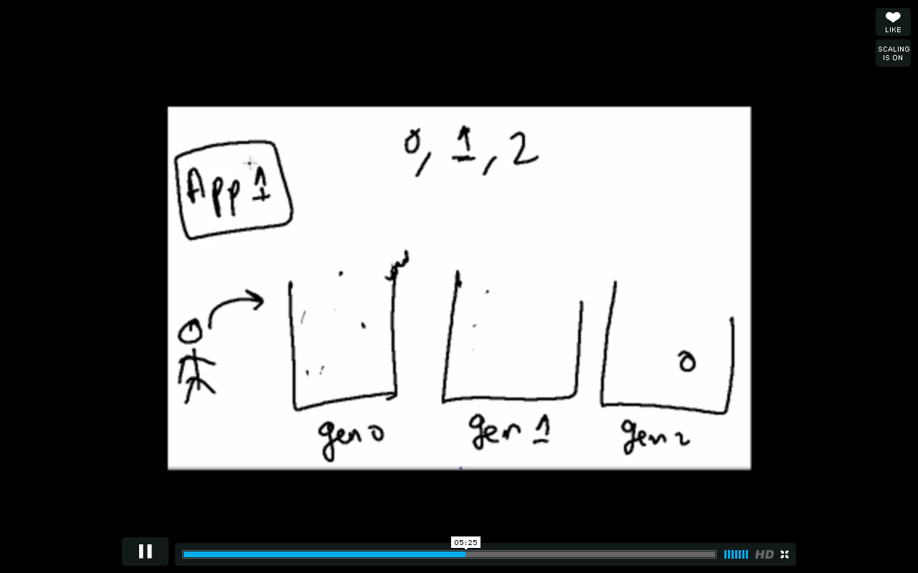

Generation 0,1,2 are used to increase the performance of the garbage collector. In order to see the managed objects there is tool called **CLRProfiler.**

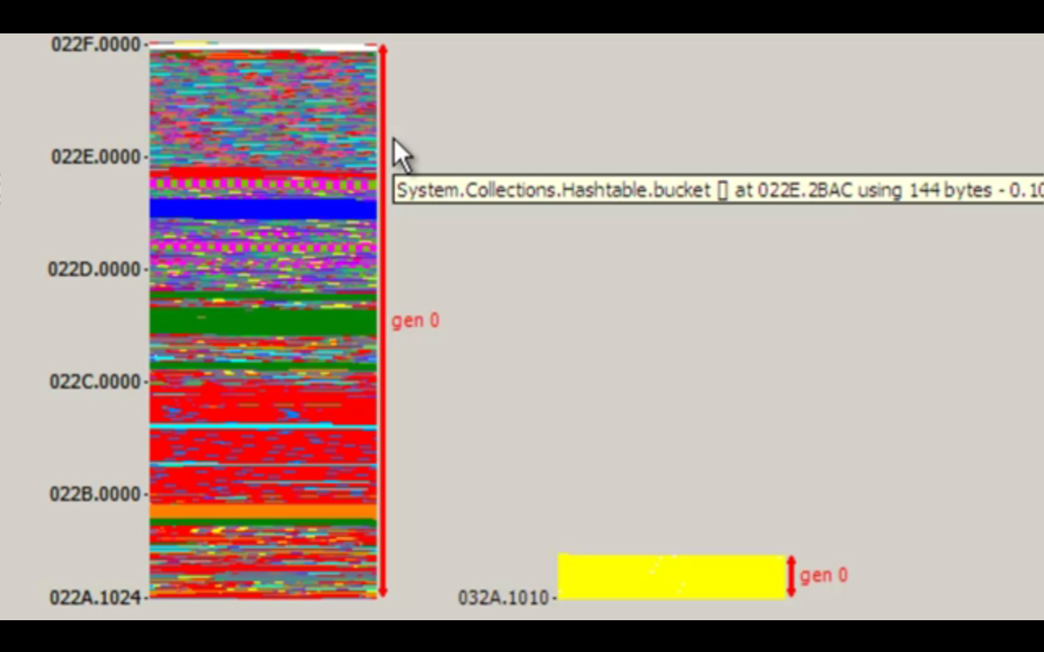

1. [What is IDisposable interface & finalize dispose pattern in GC?](http://www.questpondvd.com/02456subcategquureutnpaotnhd9854.php?pp=306&propid=8&saleid=subscription)

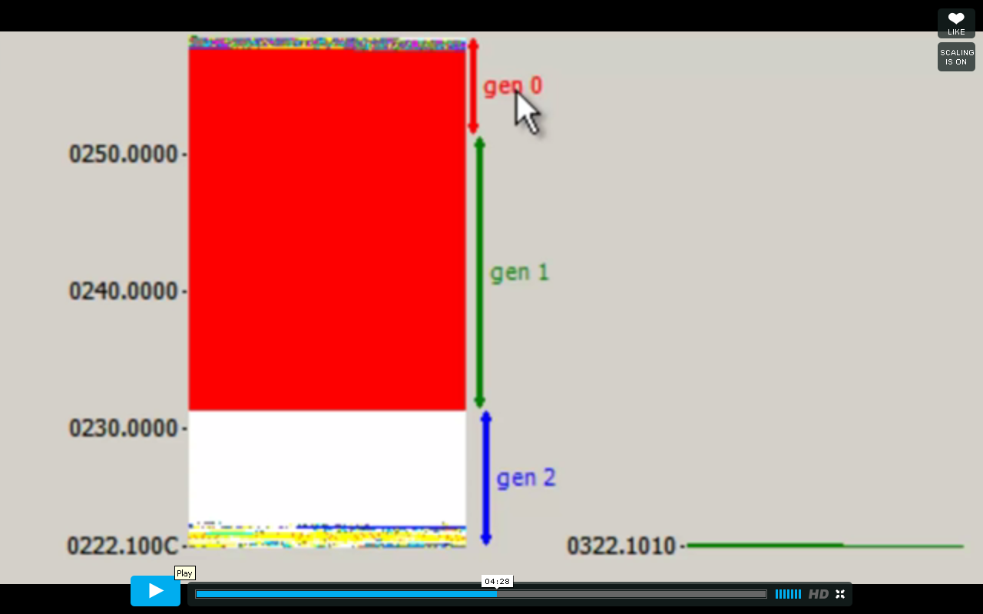

Every time the garbage collector ask question whether you have defined any destructor in your class,If you defined the destructor in your class then it won’t cleanup the object directly. It will move the objects to generation 1 and 2 which is not proper way of managing memory.

private void button1_click(object sender,EventArgs e)

{

for(int i=0;i<100000;i++)

{

cls1 obj = new cls1();

}

}

Public class cls1

{

~cls1(){ }

}

This problem can be overcome by using **finalize dispose pattern**.

private void button1_click(object sender,EventArgs e)

{

for(int i=0;i<100000;i++)

{

cls1 obj = new cls1();

obj.Dispose();

}

}

Public class cls1: **IDisposable**

{

~cls1(){ }

Public void Dispose()

{

//Write your unmanged code

**GC.SuppressFinalize(true);**

}

For more information go through this link

<http://www.codeproject.com/Articles/413887/Understanding-and-Implementing-IDisposable-Interfa>

or <https://docs.google.com/document/d/1J8tk95Y_EdqGg9518Xv9s-oGLKRGtK2D_se1FHyeGi0/edit>

1. [What is the difference between strong and weak references?](http://www.questpondvd.com/02456subcategquureutnpaotnhd9854.php?pp=307&propid=9&saleid=subscription)

Weak references are without strong name and strong references are with strong name. The client exe identifies the dll using strong name.

1. [What is delay signing?](http://www.questpondvd.com/02456subcategquureutnpaotnhd9854.php?pp=308&propid=10&saleid=subscription)

When we talk about the Assembly then the first thing comes into our mind is the security for high level development. Delayed signing is the terminology when we are certifying the assembly which will prevent hi-jacking of that assembly.

Delayed signing refers to a technique of partially signing assemblies while they are in development phase. So, signing an assembly basically certifies that assembly by the manufacturer and prevents tampering and hi-jacking of that assembly. This is achievable by using public key/private key encoding of parts of the assembly. The public key is embedded in the assembly and will be used by third-parties who want to reference the assembly. There are many more benefits to signing an assembly, but the main purpose of delayed signing is to allow a company to protect and control its private key and only use it during the packaging process. A delayed signed assembly can still be used like a signed assembly, you just can't package and ship it.

Steps to certify the Assembly:-

Delays sign a .NET app:

* + sn -k keypair.snk
  + sn -p keypair.snk public.snk
  + Build assembly with:  
    [assembly: AssemblyDelaySign("false")]   
    [assembly: AssemblyKeyFile("..\\..\\keypair.snk")]
  + sn -Vr AssemblyName.dll
  + This step is critical and is not mentioned anywhere. Exit and restart every instance of VisualStudio running. Until you do this Visual Studio will not know of the sn -Vr from step 4 and you will get  
    "COM Interop registration failed. The check of the signature failed for assembly AssemblyName.dll"

1. [Can we see simple example of GAC & How to handle multiple versions in GAC?](http://www.questpondvd.com/02456subcategquureutnpaotnhd9854.php?pp=309&propid=11&saleid=subscription)

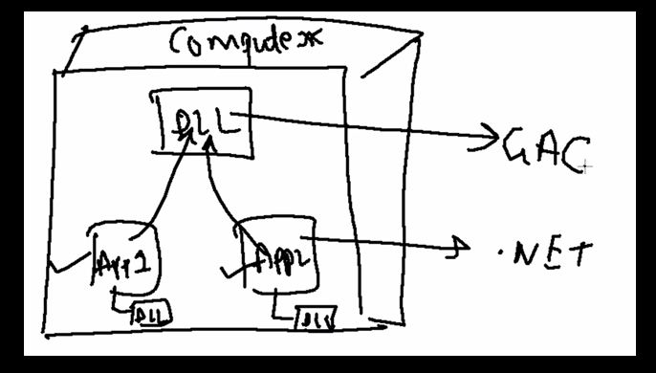

Global Assembly Cache is a place where multiple dlls can be registered or placed or shared, which can be used by other .NET applications running on this server.

To register the dll into the GAC, you need to strong name the dll and use the gacutil tool .

Multiple versions in GAC – Change the version of the dll in the assembly info class and build the dll and place it in the GAC.

Use the .net framework configuration tool to attach the particular version of dll to the application as shown in the below screen shot, It creates a configuration (Binding Redirect) file which maps the version from old to new.

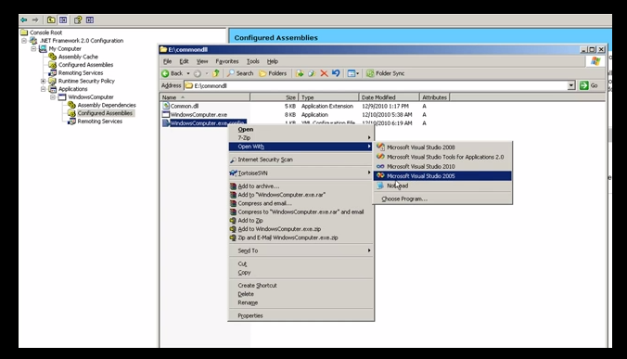

1. [What are different .NET datatypes and its uses according to scenarios?](http://www.questpondvd.com/02456subcategquureutnpaotnhd9854.php?pp=388&propid=12&saleid=subscription)
2. What is difference between String and string?

String is alias of String (Capital String)

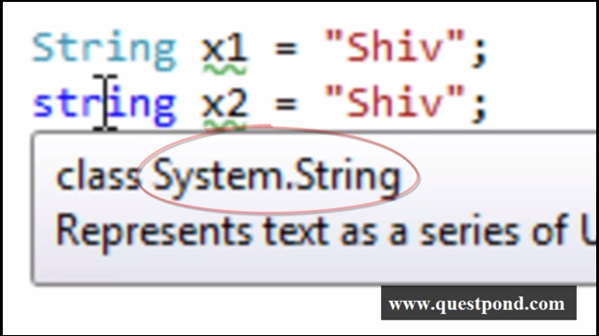 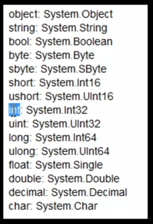

1. [What is difference between String and stringBuilder?](http://www.questpondvd.com/02456subcategquureutnpaotnhd9854.php?pp=501&propid=13&saleid=subscription)

Strings are immutable.

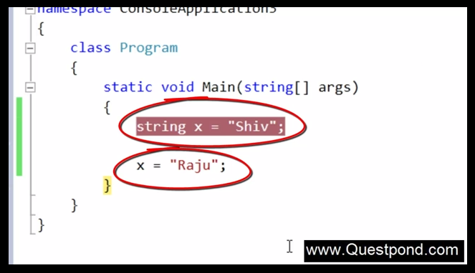

Here initially “Shiv” is assigned to x and then “Raju” is overwritten to x. But here there are two memory chuck are allocated separately to x variable. The string variables are immutable, immutable means the value does not change. **Immutable designed was made by Microsoft for Thread safety.**

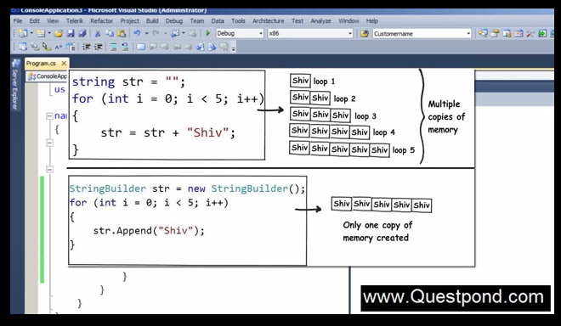

We can use **String Builder** in the above scenario i.e. when the string value is change again and again.

**String**  
1.It’s a class used to handle strings.  
2. Here concatenation is used to combine two strings.  
3. String object is used to concatenate two strings.  
4. The first string is combined to the other string by creating a new copy in the memory as a string object, and then the old   
string is deleted  
5.That is why “Strings are immutable".  
6. Slower  
  
**String Builder**  
1.This is also the class used to handle strings.  
2. Here Append method is used.  
3. Here, String builder object is used.  
4. Insertion is done on the existing string.  
5. Usage of String Builder is more efficient in case large amounts of string manipulations have to be performed.  
6. Faster

1. [What problem does Delegate Solve? - Part1](http://www.questpondvd.com/02456subcategquureutnpaotnhd9854.php?pp=243&propid=15&saleid=subscription)
2. [What is a Multicast delegate? - Part2](http://www.questpondvd.com/02456subcategquureutnpaotnhd9854.php?pp=244&propid=16&saleid=subscription)
3. [What are events & what's the difference between delegates & events? - Part3](http://www.questpondvd.com/02456subcategquureutnpaotnhd9854.php?pp=245&propid=17&saleid=subscription)
4. [How can we make Asynchronous method calls using delegates?](http://www.questpondvd.com/02456subcategquureutnpaotnhd9854.php?pp=246&propid=18&saleid=subscription)

Delegates are pointers to methods. Delegate encapsulates the method, you can use those delegates to invoke the methods.

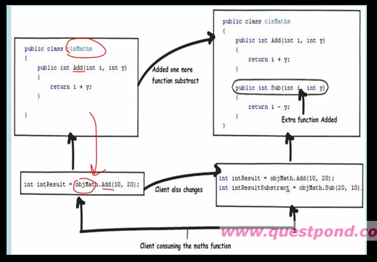

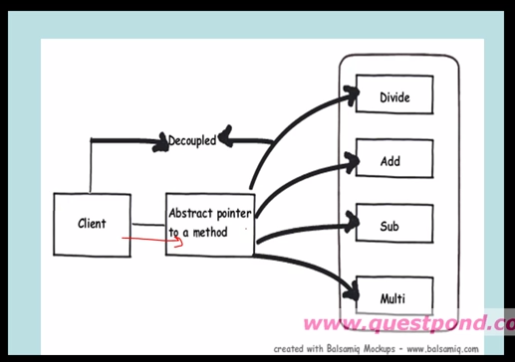

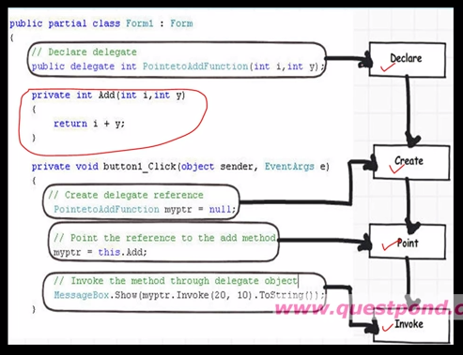

Multicast Delegates

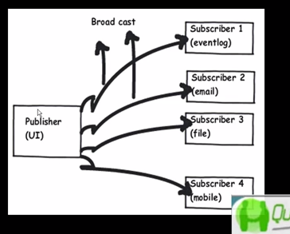

1. [What are anonymous methods in C#?](http://www.questpondvd.com/02456subcategquureutnpaotnhd9854.php?pp=373&propid=19&saleid=subscription)

Anonymous methods are very much connected to delegates. Anonymous method is coded inline. we can say, an anonymous method has only body without name, optional parameters and return type. An anonymous method behaves like a regular method and allows us to write inline code in place of explicitly named methods. Anonymous method increases the **performance**.

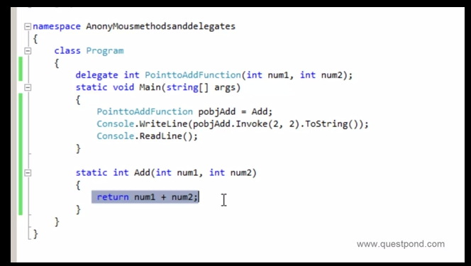

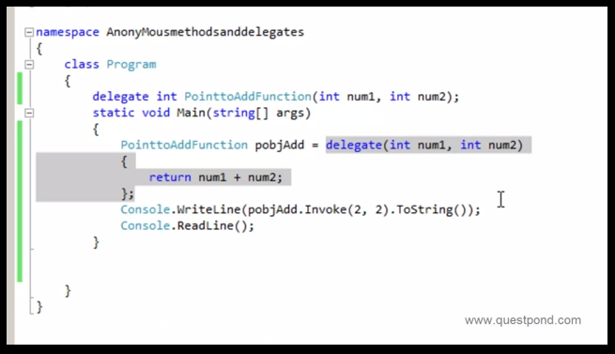

The concept of anonymous method was introduced in C# 2.0. An anonymous method is inline unnamed method in the code. It is created using the delegate keyword and doesn’t required name and return type. Hence we can say, an anonymous method has only body without name, optional parameters and return type. An anonymous method behaves like a regular method and allows us to write inline code in place of explicitly named methods.

A Simple Anonymous Method Example

1. **delegate int MathOp(int a, int b);**
2. **class Program**
3. **{**
4. ***//delegate for representing anonymous method***
5. **delegate int del(int x, int y);**
7. **static void Main(string[] args)**
8. **{**
9. ***//anonymous method using delegate keyword***
10. **del d1 = delegate(int x, int y) { return x * y; };**
12. **int z1 = d1(2, 3);**
14. **Console.WriteLine(z1);**
15. **}**
16. **}**
17. ***//output:***
18. **6**

Key points about anonymous method

1. A variable, declared outside the anonymous method can be accessed inside the anonymous method.
2. A variable, declared inside the anonymous method can’t be accessed outside the anonymous method.
3. We use anonymous method in event handling.
4. An anonymous method, declared without parenthesis can be assigned to a delegate with any signature.
5. Unsafe code can’t be accessed within an anonymous method.
6. An anonymous method can’t access the ref or out parameters of an outer scope.

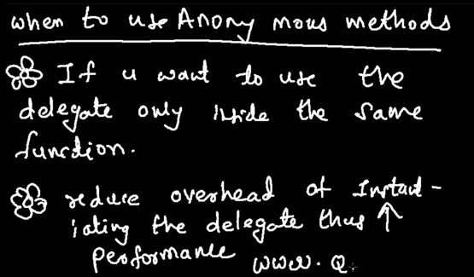

1. [Why anonymous types are preferred over Tuples?](http://www.questpondvd.com/02456subcategquureutnpaotnhd9854.php?pp=376&propid=20&saleid=subscription)

**Tuples**

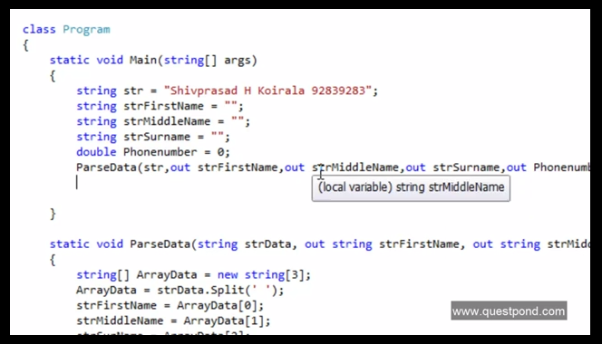

The above code is very lengthy because so many variables are declared and used. **Instead group those variables in one logical unit.** That is where Tuples helps us. Tuples are nothing but object which helps us to logically group the other objects.

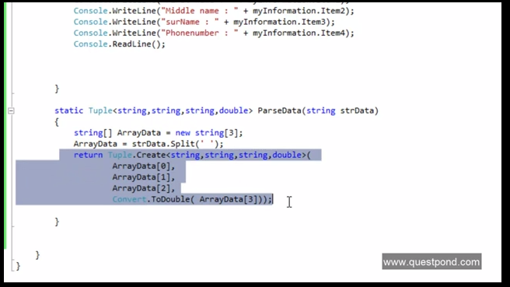

Here disadvantage of Tuple is, while accessing the each item of the tuple object we need to remember the sequence of the items. In the **Anonymous Type** on the fly you can declare the variables and use as shown below:

* + return new

{

FirstName = ArrayData[0],

MiddleName = ArrayData[1],

LastName = ArrayData[2],

PhoneNumber = ArrayData[3]

};

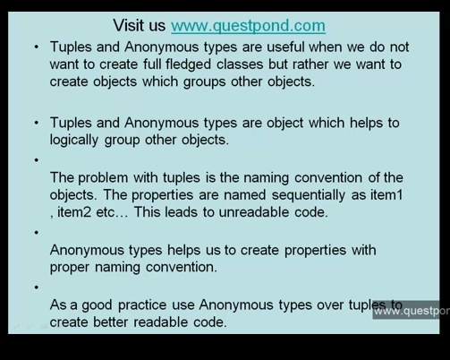

1. [What is the use of Lambda Expression Action<>, Predicate<> & Func<>?](http://www.questpondvd.com/02456subcategquureutnpaotnhd9854.php?pp=571&propid=21&saleid=subscription)

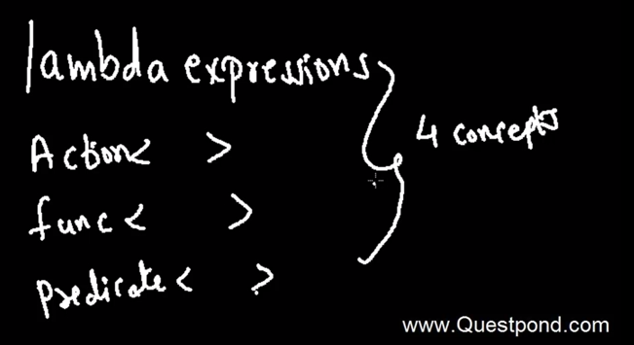

These 4 concepts are used in the below scenarios:

* + Lambda Expression, Action,Func,Predicate **make your delegate code more simple**.
  + Lambda Expression helps to build **Expression trees**- LINQ and Business Languages

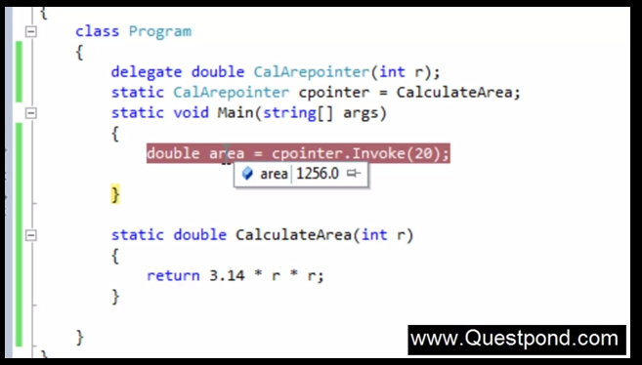

Let’s see, how we can simplify the above code:

* + **Using Anonymous Method**

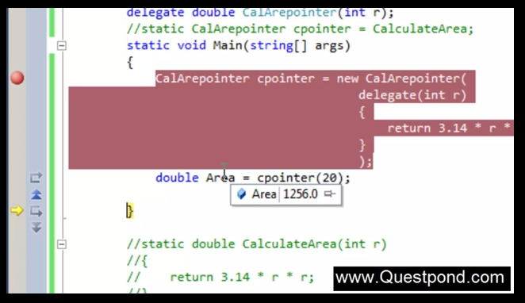

* + Using Lambda Expression

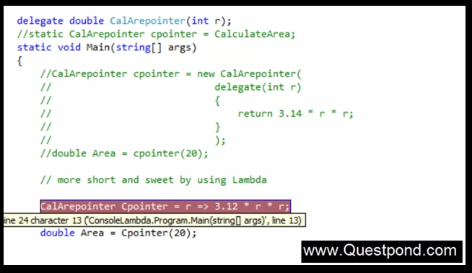

* + **Using Generic Delegates (func)** – Its takes the input and gives you output , here **input** double and **output** double

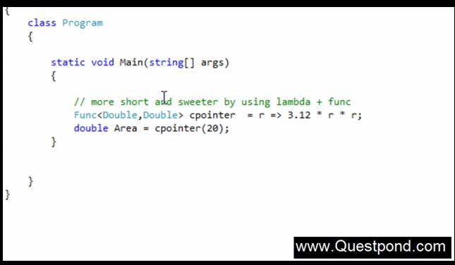

* + **Using Action<>** - It takes input and won’t return output, **input** int and **output** void



* + **Using Predicate<> - It’s a extension of func<>. Using this you can check the return type**



**Expression Tree**

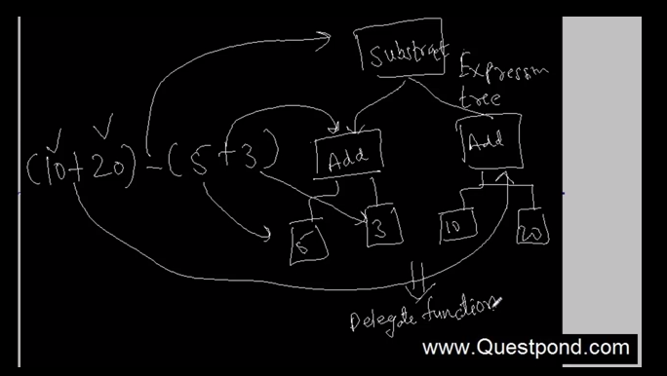

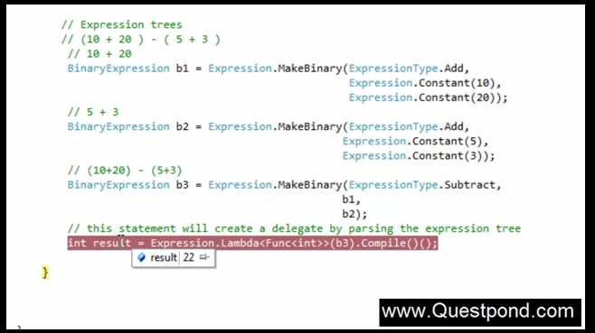

1. [What do you mean by Covariance & Contravariance in .NET 4.0?](http://www.questpondvd.com/02456subcategquureutnpaotnhd9854.php?pp=595&propid=22&saleid=subscription)

Dynamic Polymorphism

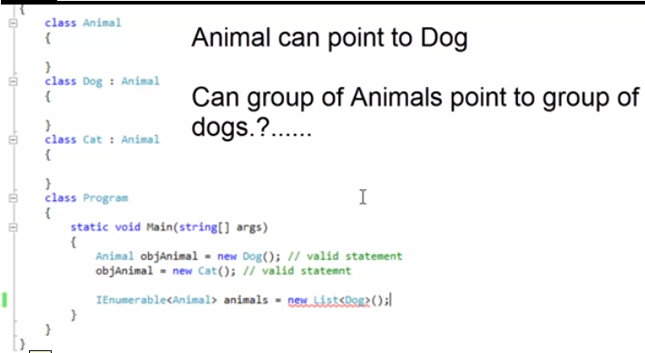

**The above code was not valid in .net 3.5. Covariance** – Allows you to do things in your code that previously you were surprised you could not do. Its valid in **.net 4.0.**

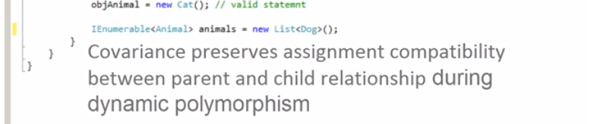

**Contravariance** is exactly opposite to Covariance.

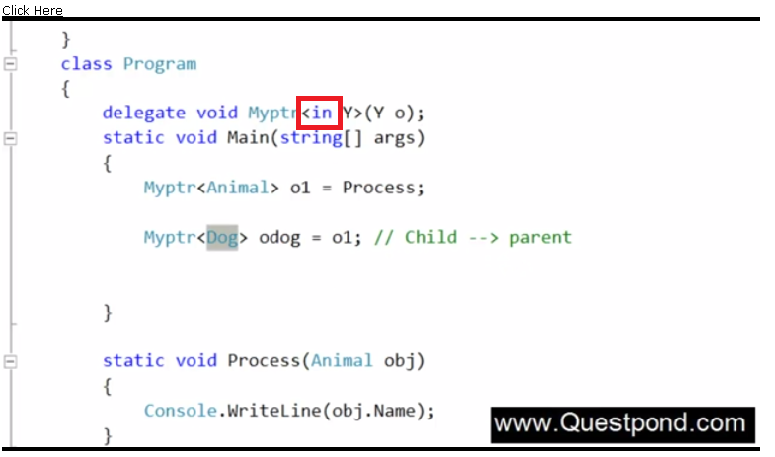

1. [What is the use of checked and unchecked keyword?](http://www.questpondvd.com/02456subcategquureutnpaotnhd9854.php?pp=381&propid=23&saleid=subscription)

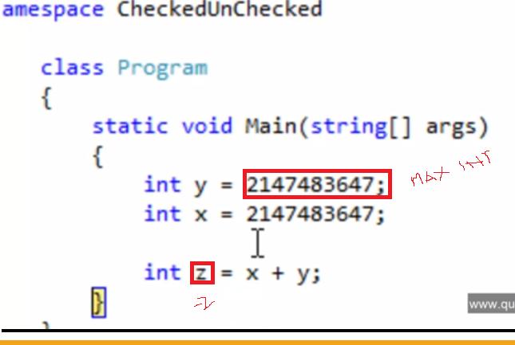

Here maximum value of int is 2147483647, when we add these two values x and y the output z comes as -2. It won’t throw overflow exception. In this case we can use **Checked keyword.** It will throw exception.

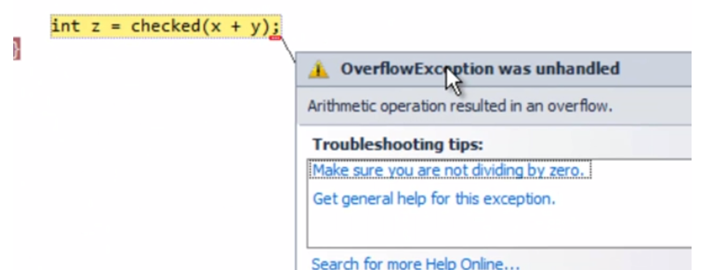

**Unchecked** keyword behaves as default behavior.

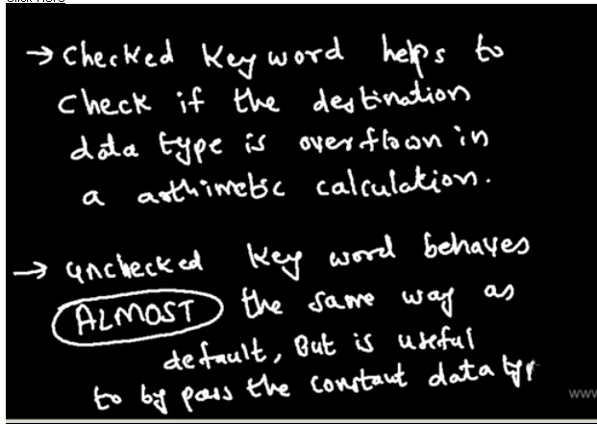

1. [What is a stack, Heap, Value types and Reference types?](http://www.questpondvd.com/02456subcategquureutnpaotnhd9854.php?pp=247&propid=24&saleid=subscription)

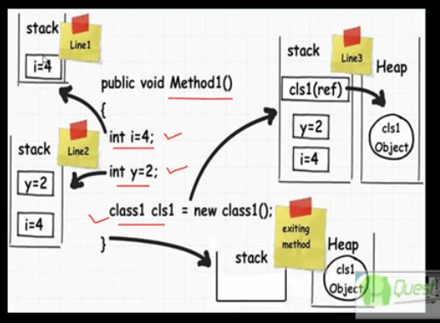

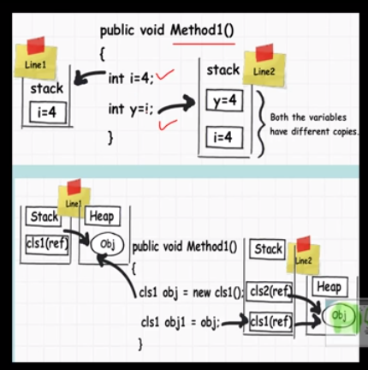

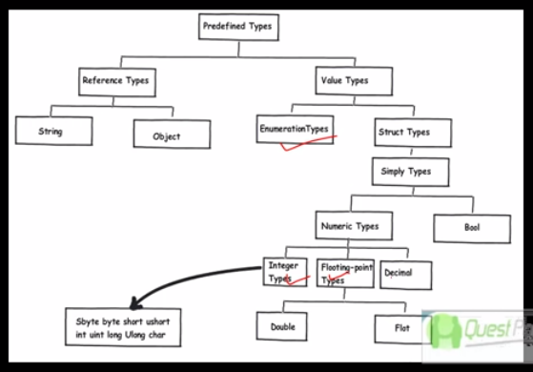

1. [What is boxing and unboxing?](http://www.questpondvd.com/02456subcategquureutnpaotnhd9854.php?pp=248&propid=25&saleid=subscription)

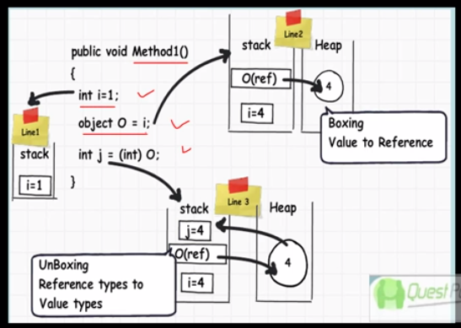

1. [What is optimistic and pessimistic locking? - Part1](http://www.questpondvd.com/02456subcategquureutnpaotnhd9854.php?pp=291&propid=26&saleid=subscription)
2. [Can you explain optimistic locking? - Part2](http://www.questpondvd.com/02456subcategquureutnpaotnhd9854.php?pp=294&propid=27&saleid=subscription)
3. [Can you explain pessimistic locking? - Part3](http://www.questpondvd.com/02456subcategquureutnpaotnhd9854.php?pp=295&propid=28&saleid=subscription)

These are the problem happens when **concurrency**(Simultaneously more than one users accessing a data ) happens.

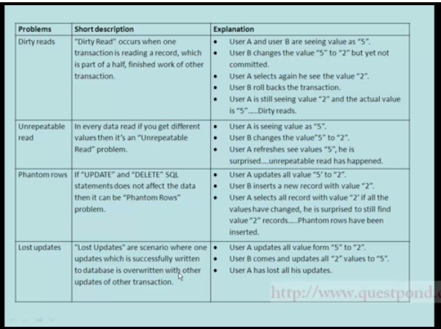

These problems can be resolved by using Optimistic and Pessimistic locking.

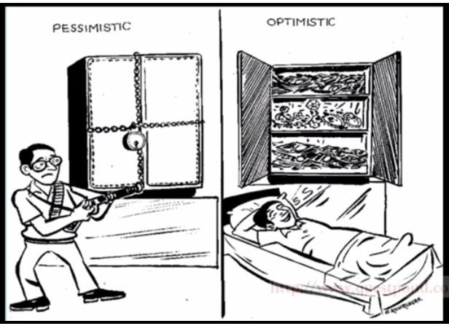

Optimistic lock assumes that the transaction will work without locking (i.e. read the record whether updated or not and then work on the record.) whereas in Pessimistic locking we assume that concurrency will happened and we lock the record , then work on that record.

**Optimistic locking –**

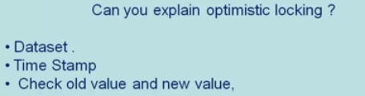

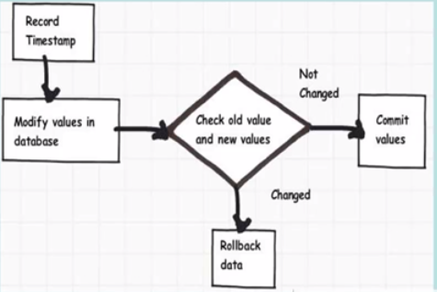

**Pessimistic Locking –**

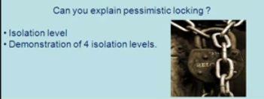

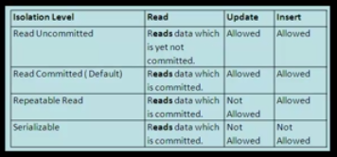

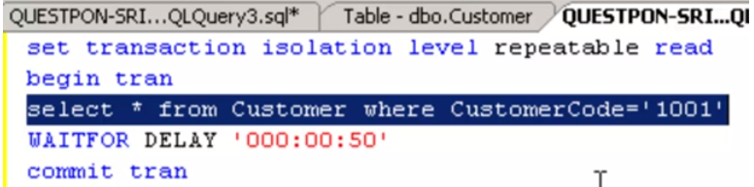

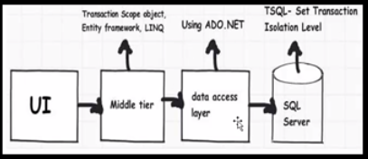

1. [What are regular expressions & can we see some practical demonstrations?](http://www.questpondvd.com/02456subcategquureutnpaotnhd9854.php?pp=342&propid=29&saleid=subscription)

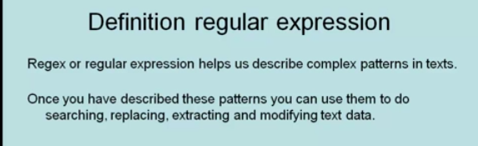

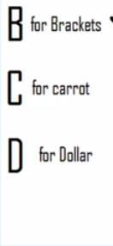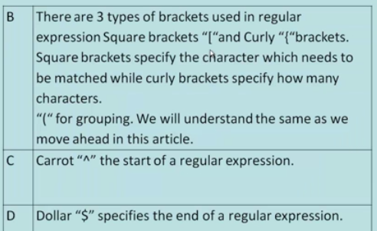

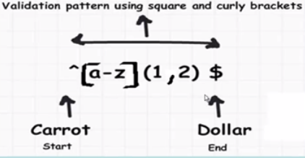

1. [What are the different types of collections in .NET?- Part 1](http://www.questpondvd.com/02456subcategquureutnpaotnhd9854.php?pp=344&propid=30&saleid=subscription)

Collections are group of record that can treated as one logical unit. .NET collections are categorized as below:

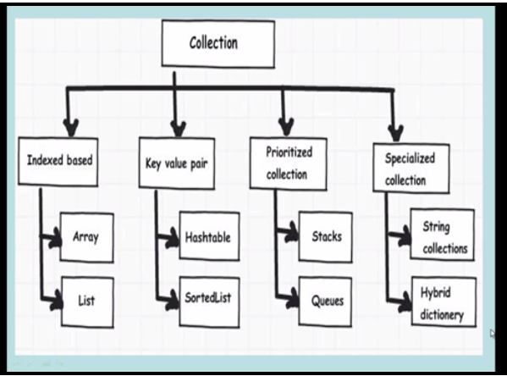

**Indexed based and Key value pair**

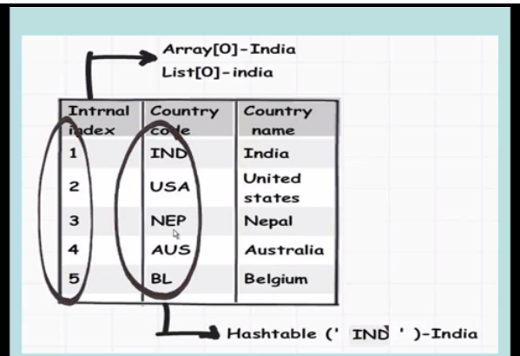

**Prioritized collection**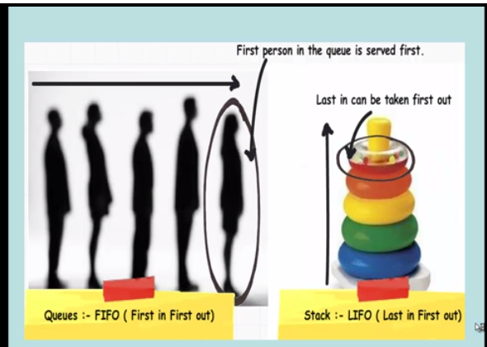

1. [What is the difference between Array & ArrayList?- Part 2](http://www.questpondvd.com/02456subcategquureutnpaotnhd9854.php?pp=345&propid=31&saleid=subscription)

**Array** has **fixed size** and **strongly typed** and it needs cryptic code like forloop etc.

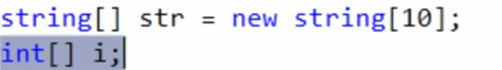

**ArrayList** overcomes all these disadvantages of Array. It has **Add**, **Remove** etc methods.





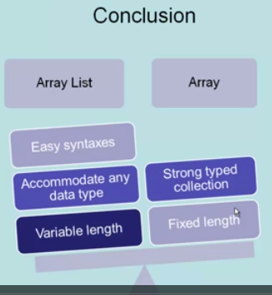

1. [Can you prove why arrays are faster than arraylist?- Part 3](http://www.questpondvd.com/02456subcategquureutnpaotnhd9854.php?pp=346&propid=32&saleid=subscription)
2. [What are the problems with arraylist & how can we solve the same by Hashtables?- Part 4](http://www.questpondvd.com/02456subcategquureutnpaotnhd9854.php?pp=347&propid=33&saleid=subscription)

We have to traverse through the array list using index (auto generated number), whereas in the most of the scenarios we have to access the record using key. It can be overcome by hashtable.

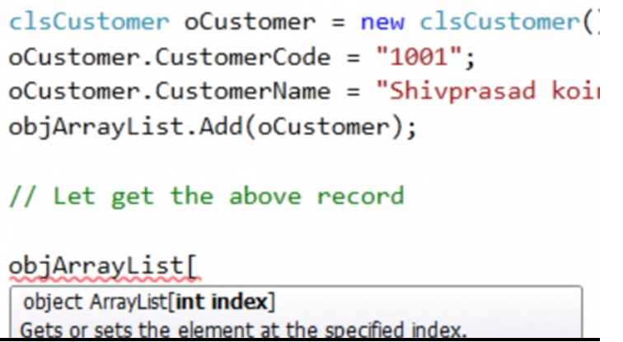 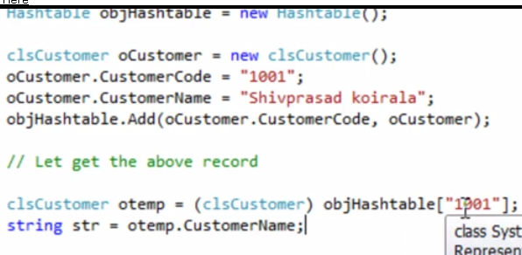

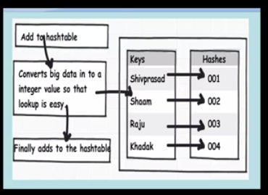 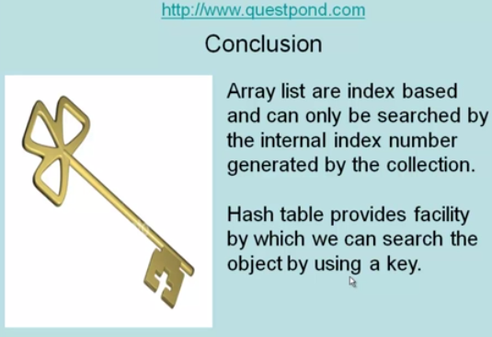

1. [What are stacks & queues?- Part 5](http://www.questpondvd.com/02456subcategquureutnpaotnhd9854.php?pp=348&propid=34&saleid=subscription)
2. [What are special collections?- Part 6](http://www.questpondvd.com/02456subcategquureutnpaotnhd9854.php?pp=349&propid=35&saleid=subscription)

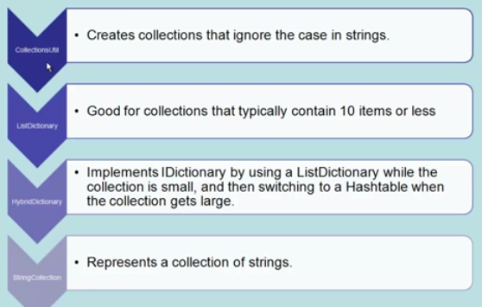

1. [What are Generics & What are generics collections?- Part 7](http://www.questpondvd.com/02456subcategquureutnpaotnhd9854.php?pp=350&propid=36&saleid=subscription)
2. [What are generics collections?- Part 8](http://www.questpondvd.com/02456subcategquureutnpaotnhd9854.php?pp=351&propid=37&saleid=subscription)

Generic collection helps us to create flexible strong typed collection.

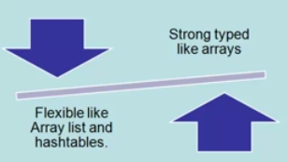

**Generics**- It separates the **logic** from the **Datatype**.

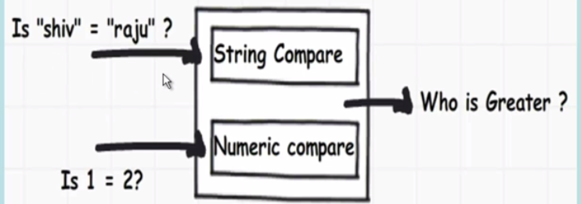

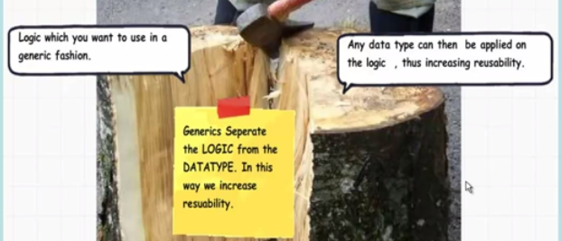

**Write the logic and at runtime, you can decide what data type you want to use as shown in the below figure:**

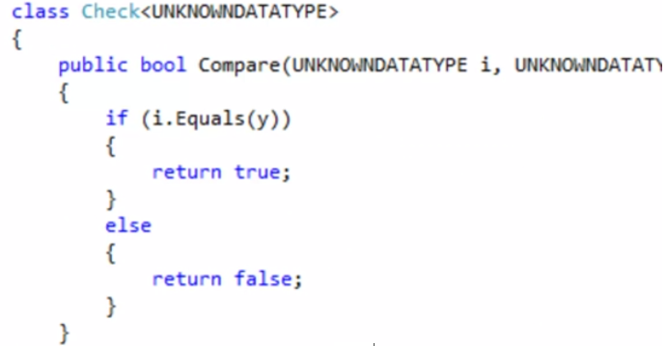

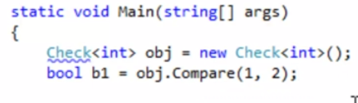

**Generic Collections:**

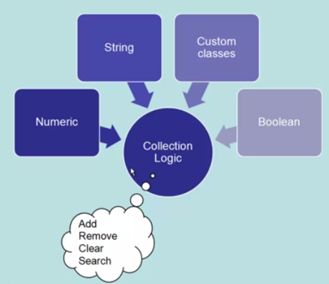 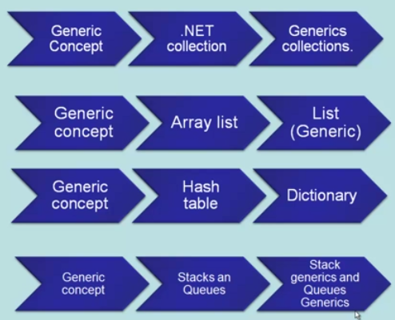

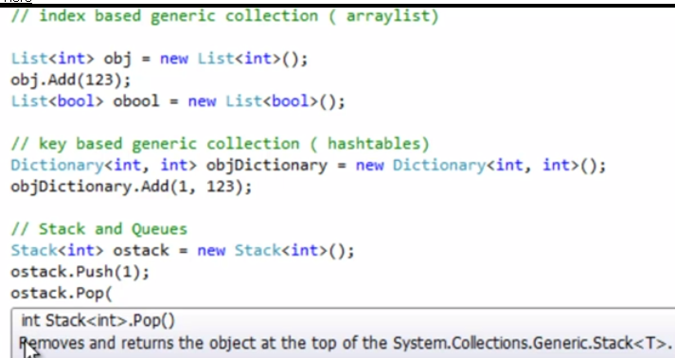

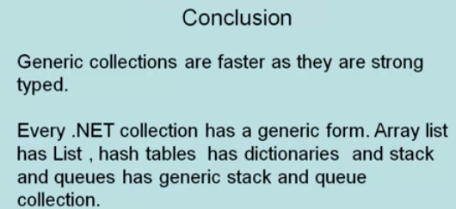

1. [What is the use of IEnumerator, ICollection, IDictionary & IList?- Part 9](http://www.questpondvd.com/02456subcategquureutnpaotnhd9854.php?pp=352&propid=38&saleid=subscription)

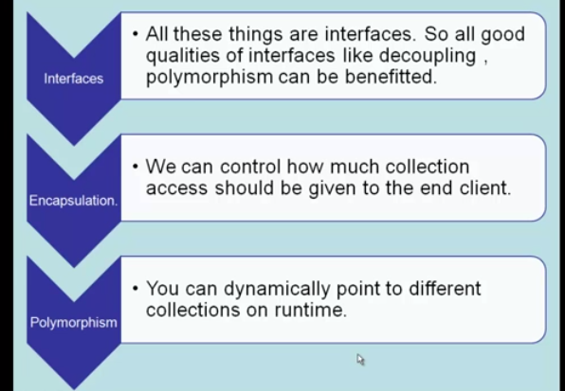



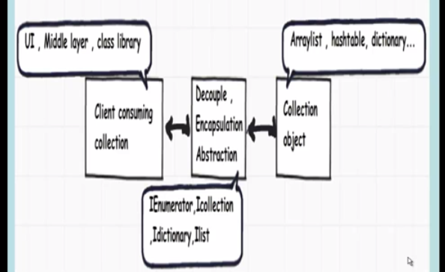

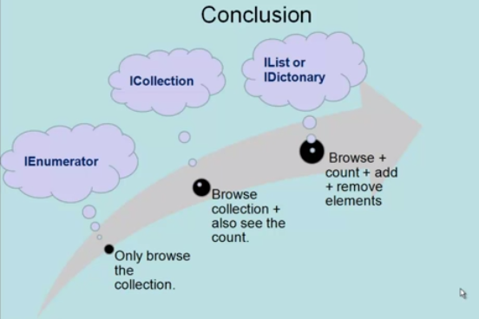

1. [What is the difference between IEnumerable and IEnumerator?](http://www.questpondvd.com/02456subcategquureutnpaotnhd9854.php?pp=592&propid=39&saleid=subscription)

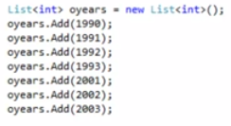

**IEnumerable**

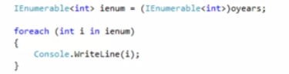

**IEnumerator**

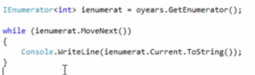

**IEnumerable** uses **IEnumerator** internally.

Here are few points which I learnt about IEnumerable and IEnumerator.

1. IEnumerable uses IEnumerator internally.
2. IEnumerable doesn’t know which item/object is executing.
3. Whenever we pass IEnumerator to another function ,it knows the current position of item/object.
4. Whenever we pass IEnumerable collection to another function ,it doesn't know the current position of item/object(doesn't know where I am)
5. IEnumerable have one method GetEnumerator()

IEnumerator have one Property current and two methods Reset and MoveNext.

In simple words: If you want to loop through with the collection one by one and you are not interested in the current cursor position then should opt

Enumerable.Because code is simple and short.

And if you are keen to know the current position of object then should go for IEnumerate.

1. [5 tips to improve your C# debugging.](http://www.questpondvd.com/02456subcategquureutnpaotnhd9854.php?pp=383&propid=40&saleid=subscription)
2. [Can you explain Named Parameters, Ref, Out, Volatile & Parsetry?](http://www.questpondvd.com/02456subcategquureutnpaotnhd9854.php?pp=593&propid=41&saleid=subscription)

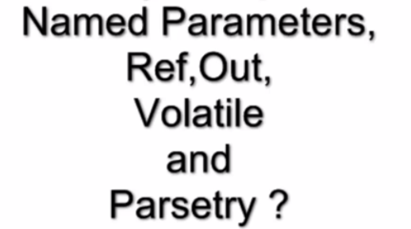

**Named Parameter**

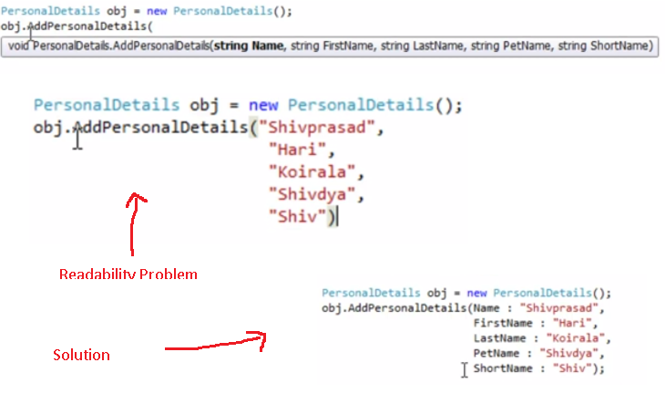

**Param Keyword –** Here in the below example the number parameters can vary, in this case we can use Param keyword.

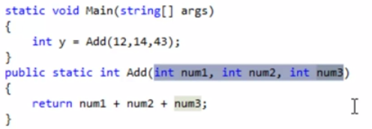

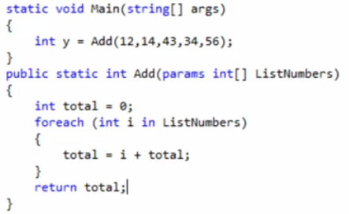

**Try Parse-** This function helps you to check the data type of the entered data, if it’s not proper data type then it returns false. For simple data type check you can use Try Parse function, it available for all the data types.

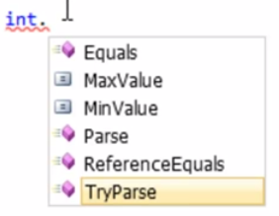

**Volatile Keyword –** This keyword can be used to avoid concurrency in multithreading.

**Ref & Out Keyword –** C# function returns one value at time. We can return multiple values using ref and out keyword.

**Ref**

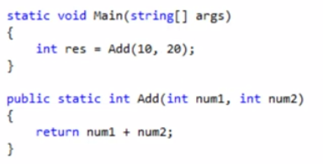

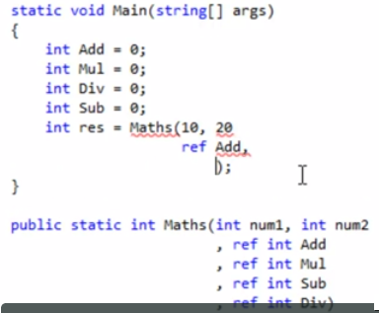

**Out**

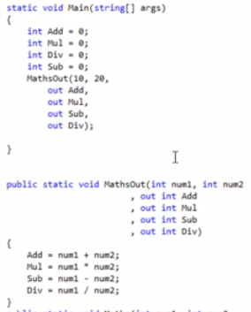

**Difference between Out and Ref**

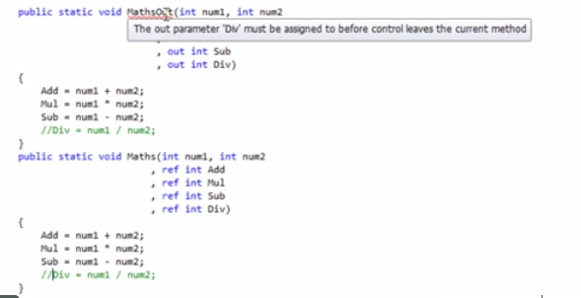

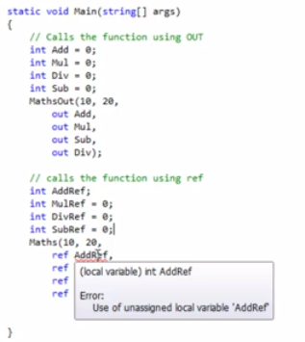

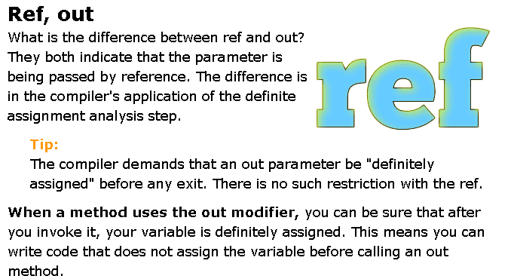

1. [What is the difference between Const & ReadOnly?](http://www.questpondvd.com/02456subcategquureutnpaotnhd9854.php?pp=603&propid=42&saleid=subscription)

Const is absolutely constant and whereas read only is constant at runtime. You can declare and change the value while programming.

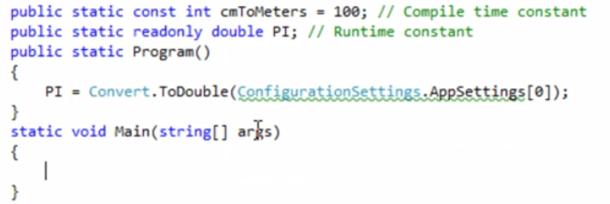

1. [What are Extension Methods?](http://www.questpondvd.com/02456subcategquureutnpaotnhd9854.php?pp=666&propid=43&saleid=subscription)

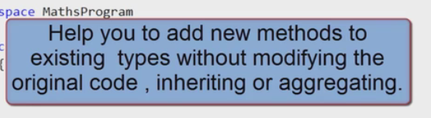

Let’s say, we have dll called Maths.dll having Add functionality, we can import this and use it in our code. If I want Subtraction functionality.

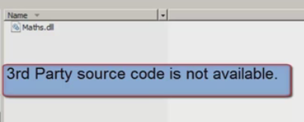



1. [What is #Debug directive?](http://www.questpondvd.com/02456subcategquureutnpaotnhd9854.php?pp=676&propid=44&saleid=subscription)

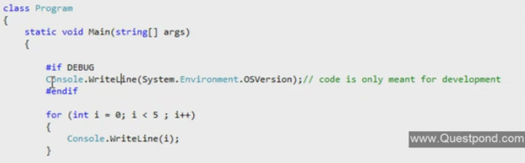

If you want to execute some block of code while development i.e. debug mode not in the release mode or production, you can use #directive as shown in the above.

1. [What is the difference between Debug and Release?](http://www.questpondvd.com/02456subcategquureutnpaotnhd9854.php?pp=677&propid=45&saleid=subscription)

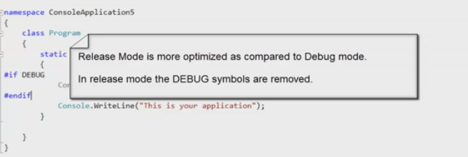

1. [What is serialization and deserialization?](http://www.questpondvd.com/02456subcategquureutnpaotnhd9854.php?pp=692&propid=46&saleid=subscription)

**Serialization & Deserialization –** Convert object to stream of bytes is Serialization and convert stream of bytes to object is called Deserialization.

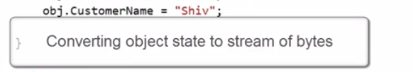

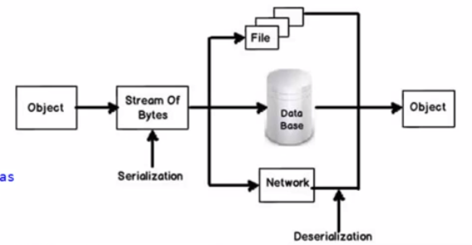

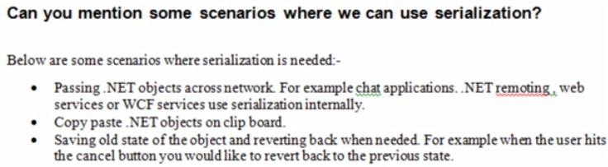

1. [What is the difference between TypeOf and GetType?](http://www.questpondvd.com/02456subcategquureutnpaotnhd9854.php?pp=729&propid=47&saleid=subscription)

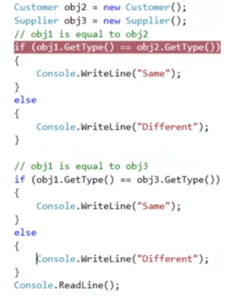

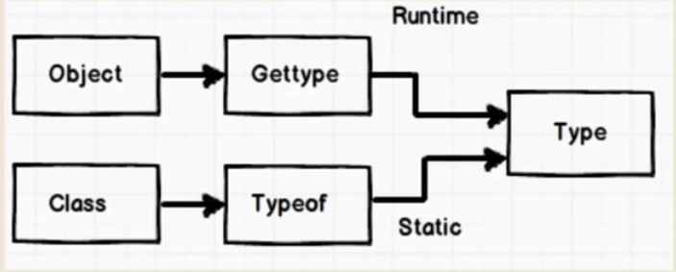

1. [What is IComparable and IComparer?](http://www.questpondvd.com/02456subcategquureutnpaotnhd9854.php?pp=736&propid=48&saleid=subscription)

**IComparable & IComparer** interface helps you to define custom sorting logic of your class. Here in the below code, sort is confused to whom to sort. **IComparable** helps you to define default sorting logic for the list. If you want to use some conditions like only by name or only by age you can use **IComparer**.

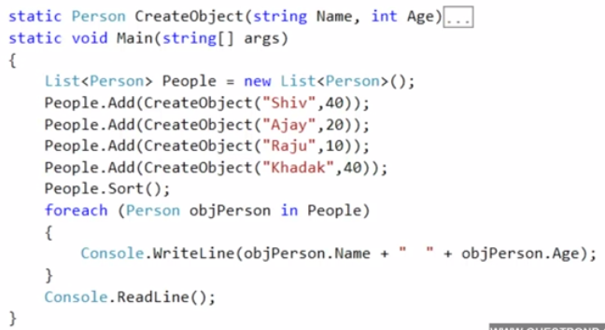

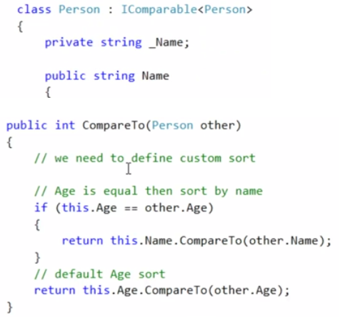

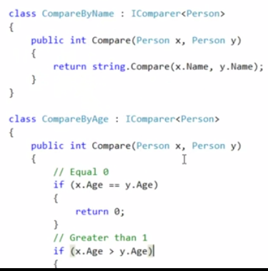

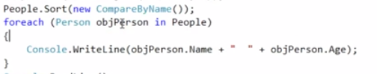

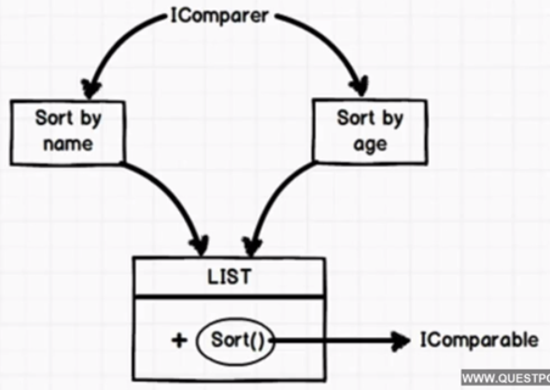

1. [What is the use of Yield Keyword in C#?](http://www.questpondvd.com/02456subcategquureutnpaotnhd9854.php?pp=750&propid=49&saleid=subscription)

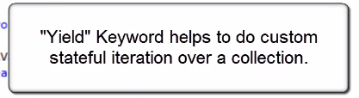

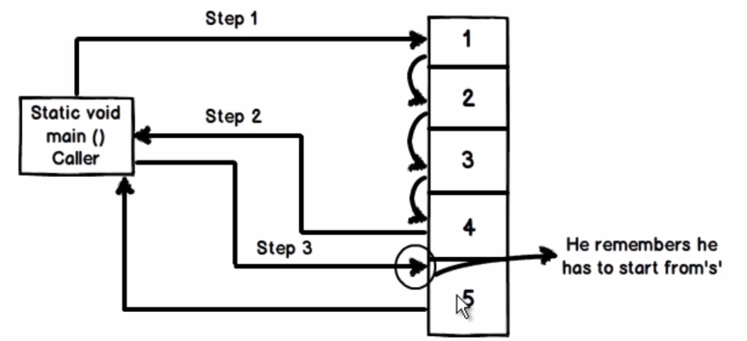

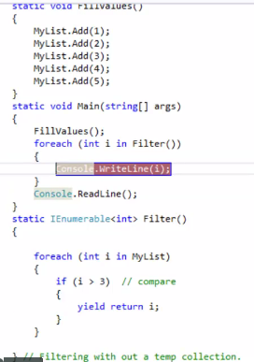

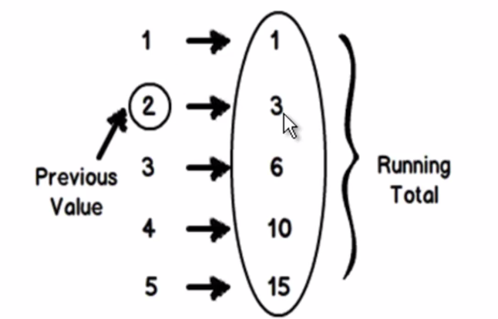

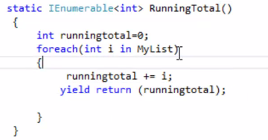

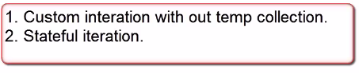

1. [What is a C# indexer?](http://www.questpondvd.com/02456subcategquureutnpaotnhd9854.php?pp=762&propid=50&saleid=subscription)

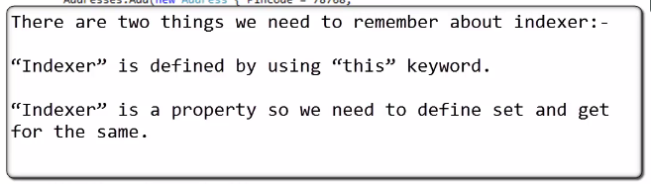

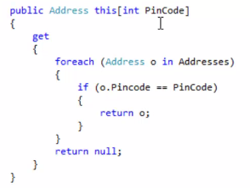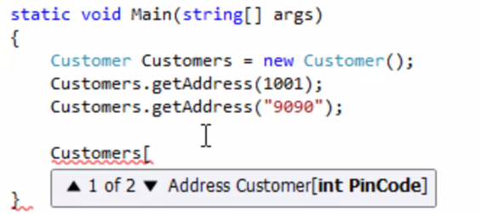

In c# introduce new concept is Indexer. This is very useful for some situation. Let as discuss something about Indexer.

* Indexer Concept is object act as an array.
* Indexer an object to be indexed in the same way as an array.
* Indexer modifier can be private, public, protected or internal.
* The return type can be any valid C# types.
* Indexers in C# must have at least one parameter. Else the compiler will generate a compilation error.

1. [What is the difference between == vs .Equals()?](http://www.questpondvd.com/02456subcategquureutnpaotnhd9854.php?pp=763&propid=51&saleid=subscription)

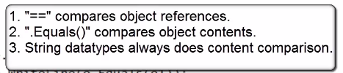

1. [What are ??(Coalescing operators)?](http://www.questpondvd.com/02456subcategquureutnpaotnhd9854.php?pp=869&propid=52&saleid=subscription)

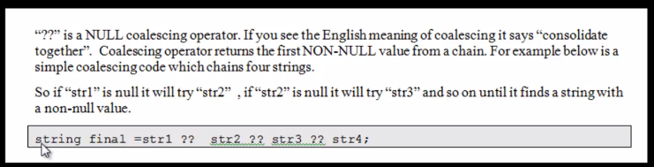

1. [What is C# reflection?](http://www.questpondvd.com/02456subcategquureutnpaotnhd9854.php?pp=781&propid=53&saleid=subscription)

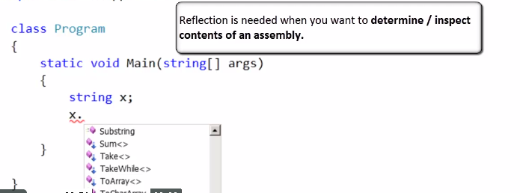

**Reflection determine/inspect contents of an assembly .**

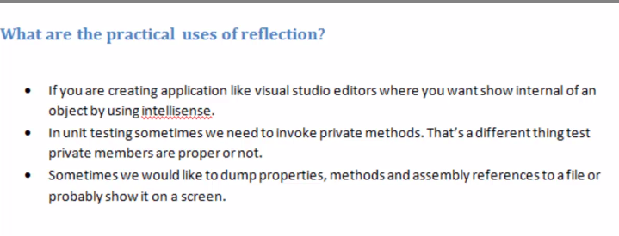

1. [What is Dynamic keyword & How does it differ from Reflection?](http://www.questpondvd.com/02456subcategquureutnpaotnhd9854.php?pp=785&propid=54&saleid=subscription)
2. [What is the difference between Early binding and Late binding?](http://www.questpondvd.com/02456subcategquureutnpaotnhd9854.php?pp=863&propid=55&saleid=subscription)

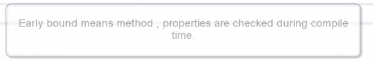

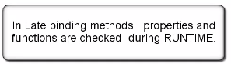

1. [What is a difference between Var and Dynamic keyword?](http://www.questpondvd.com/02456subcategquureutnpaotnhd9854.php?pp=865&propid=56&saleid=subscription)
2. [What is the use of VAR keyword in C#?](http://www.questpondvd.com/02456subcategquureutnpaotnhd9854.php?pp=379&propid=57&saleid=subscription)

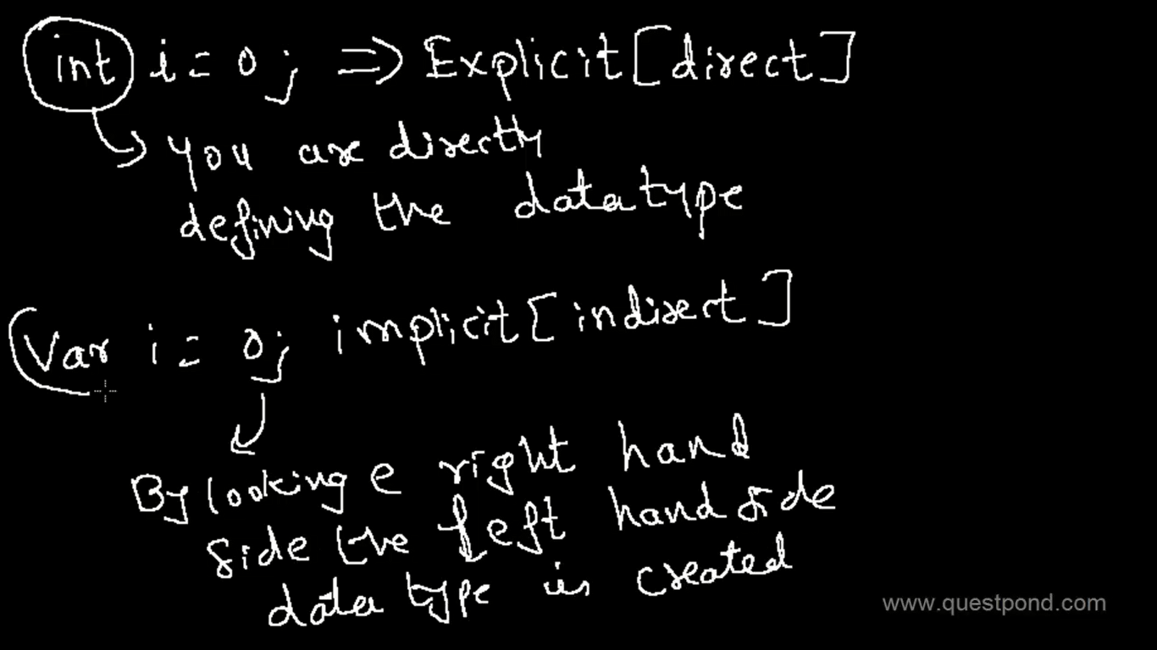

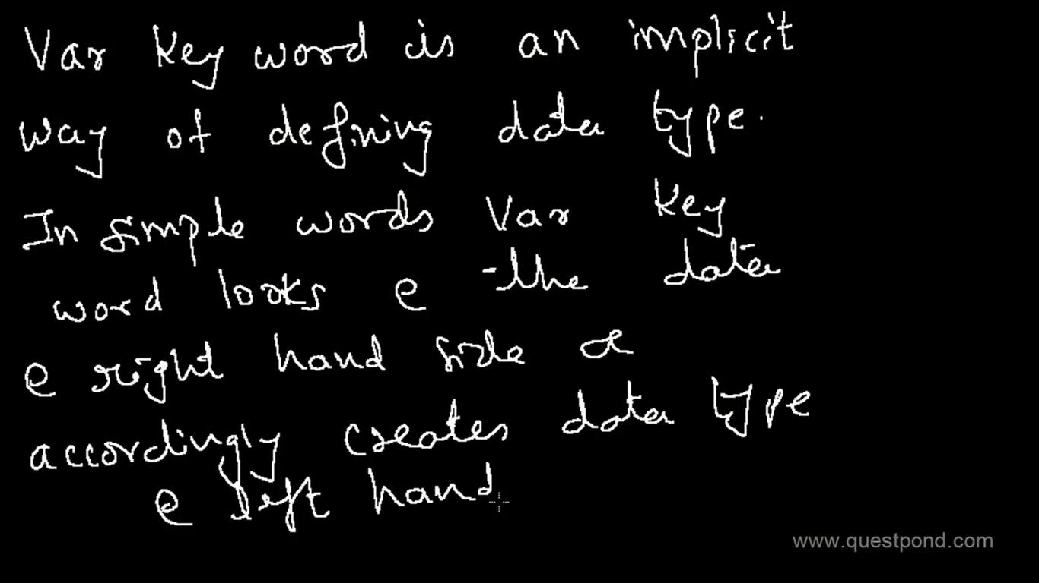

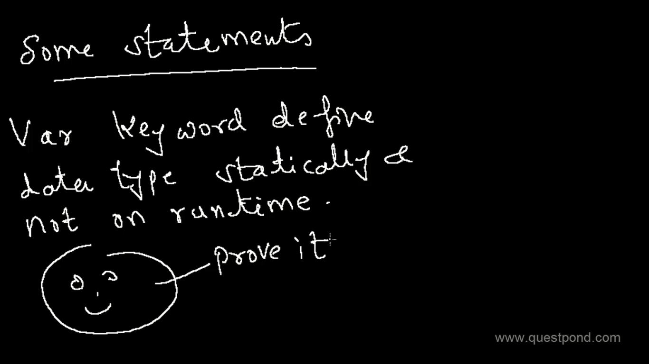

1. [What are Circular Dependencies and How to resolve them?](http://www.questpondvd.com/02456subcategquureutnpaotnhd9854.php?pp=804&propid=58&saleid=subscription)
2. [How can we mark a method as deprecated?](http://www.questpondvd.com/02456subcategquureutnpaotnhd9854.php?pp=811&propid=59&saleid=subscription)

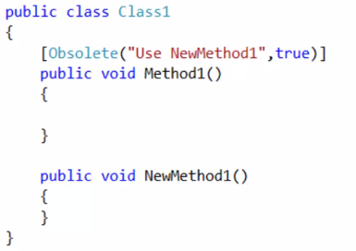

Instead of Method1() , if you want to tell the client to use NewMethod1() , Add the **Obsolete keyword.**

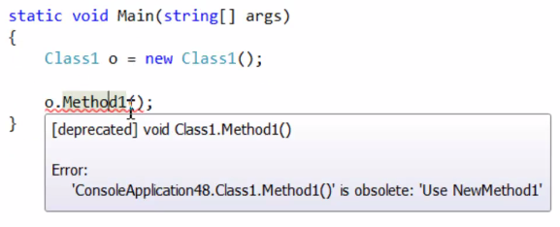

1. [What is the difference between Build VS Rebuild Vs Clean?](http://www.questpondvd.com/02456subcategquureutnpaotnhd9854.php?pp=814&propid=60&saleid=subscription)

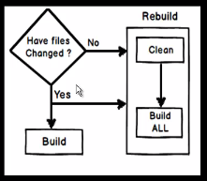



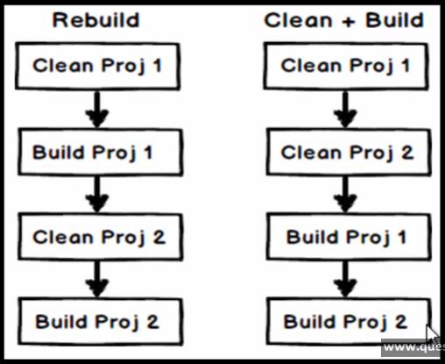

1. [What is Naming Convention?](http://www.questpondvd.com/02456subcategquureutnpaotnhd9854.php?pp=817&propid=61&saleid=subscription)
2. [What is Nuget?](http://www.questpondvd.com/02456subcategquureutnpaotnhd9854.php?pp=828&propid=62&saleid=subscription)

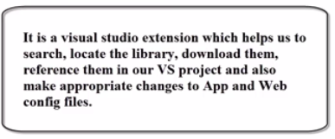

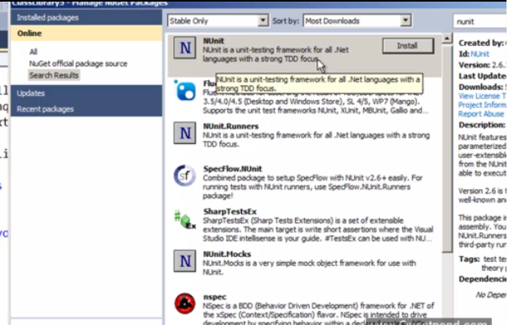

1. [What are portable class libraries?](http://www.questpondvd.com/02456subcategquureutnpaotnhd9854.php?pp=831&propid=63&saleid=subscription)

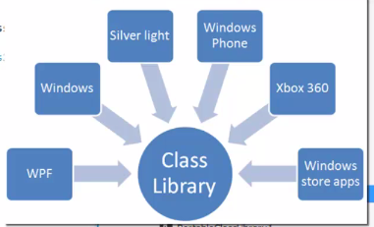

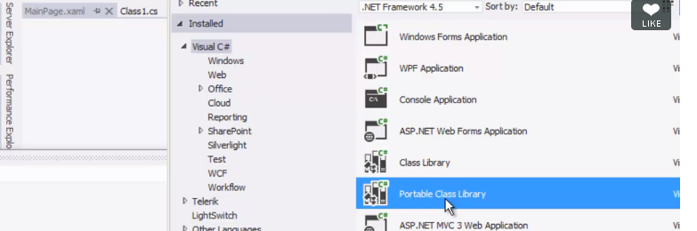

1. [What is Asynch and Await keywords?](http://www.questpondvd.com/02456subcategquureutnpaotnhd9854.php?pp=835&propid=64&saleid=subscription)
2. [What are ENUM's and flags in ENUMS?](http://www.questpondvd.com/02456subcategquureutnpaotnhd9854.php?pp=839&propid=65&saleid=subscription)
3. [How to use MSMQ with C#?](http://www.questpondvd.com/02456subcategquureutnpaotnhd9854.php?pp=841&propid=66&saleid=subscription)